**Year 8 Science: Element Research Assignment**

**Student name: ______________ Element’s name______________**

**Your task is to select one of the elements on the periodic table, and present an informative POSTER, that covers the following:**

* Name of the element
* Element symbol
* Atomic number of the element
* Two or more physical properties it possesses
* Two or more chemical properties it possesses
* When the element was discovered or created (if known).
* Who discovered the element (if known)
* Where it may be found
* Is it found as a pure substance or do we need to extract it? How?
* Some common historical uses of this element
* Some common modern uses for this element

(The uses may be of the element when it is in its pure form or when it’s combined with other elements)

* Bibliography (at least THREE sources)

You will have **2 sessions** of in-class time to research and commence the final copy of the assignment.

The rest of this assignment must be completed in your own time.

**Remember you are not allowed to copy your research notes directly from the internet or book as this is plagiarism** (stealing someone else’s work). To help prevent this you may want to write your notes in dot points in the worksheet provided.

**Due date: ________________________**

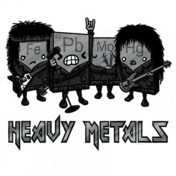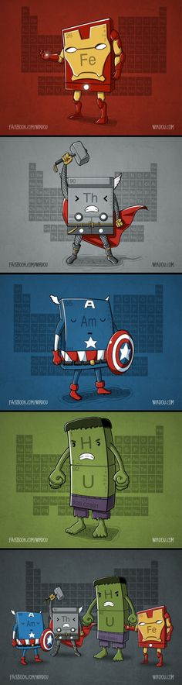***Your final copy of the assignment must be submitted in person to your teacher on or before the due date.***

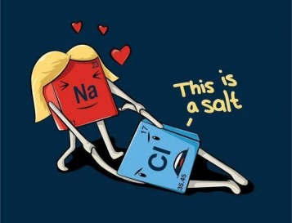

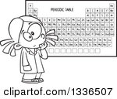**Element Research Assignment – Marking Key/ Rubric**

Name: ____________________________________

|  |  |  |  |
| --- | --- | --- | --- |
| **Assessments** |  | **Total Mark**  **Available** | **Your Mark** |
| Name of the element |  | 1 |  |
| Element symbol |  | 1 |  |
| Atomic number |  | 1 |  |
| Physical properties | 1 mark per property, max 2 marks | 2 |  |
| Chemical properties | 1 mark per property, max 2 marks | 2 |  |
| Discovery date |  | 1 |  |
| Person who discovered it |  | 1 |  |
| Where can it be found? |  | 1 |  |
| How we can extracted from where it is found? | Brief description | 2 |  |
| Common historical uses | 1 mark per use, max 2 marks | 2 |  |
| Common modern uses | 1 mark per use, max 2 marks | 2 |  |
| Bibliography:  (minimum **3** websites or books) | 3 websites/ books  Correct style | 3  1 |  |
| **Total Mark** |  | **20** |  |

Comment:_____________________________________________________________________________________________________________________________________________